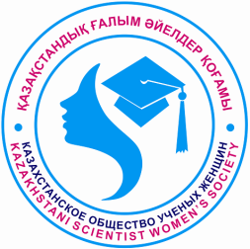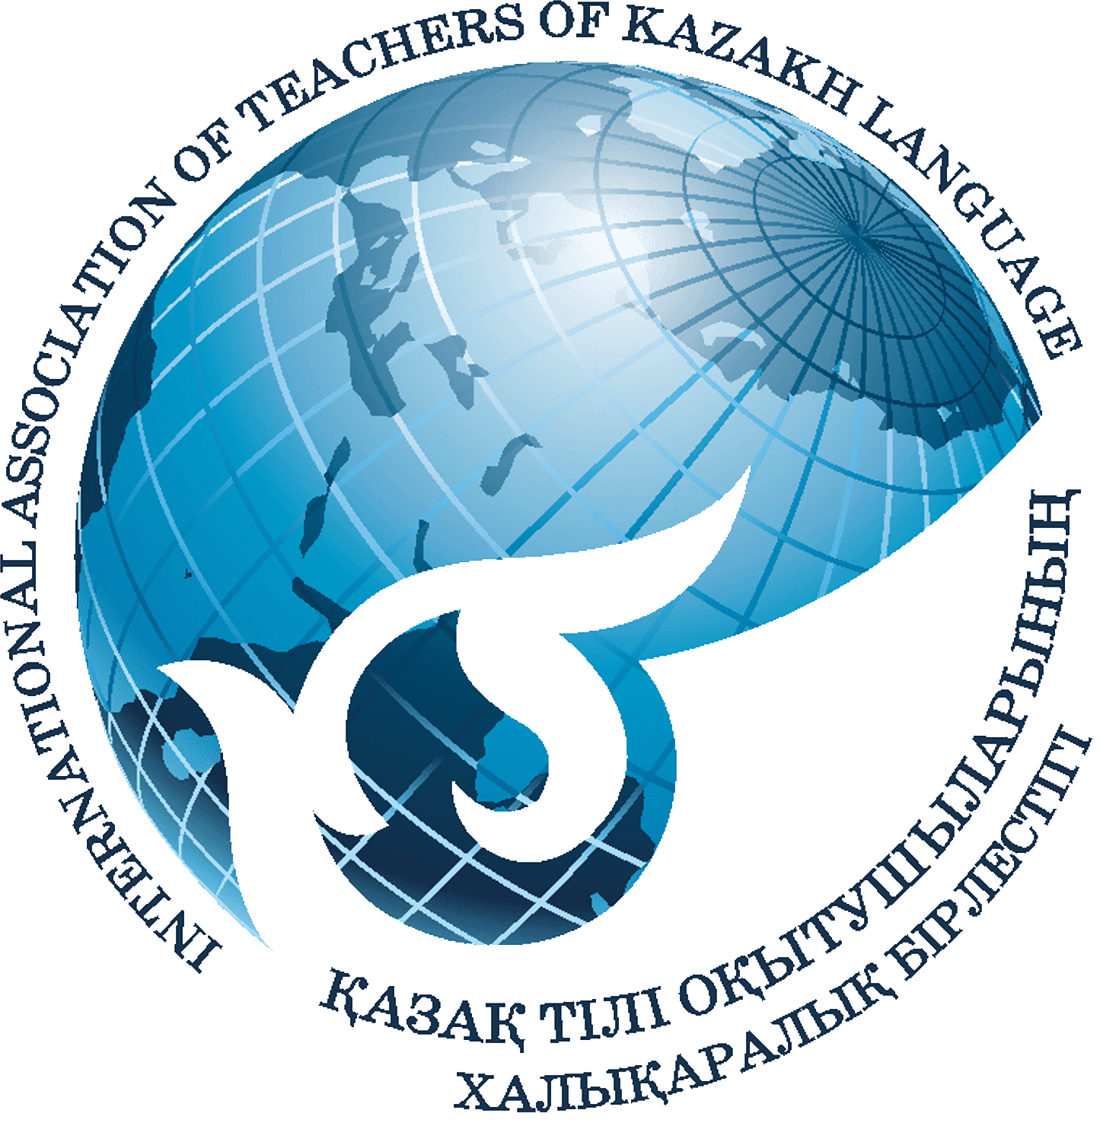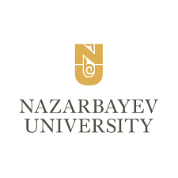

**INFORMATION LETTER**

On April 25, 2025, Nazarbayev University will hold an international scientific and practical conference entitled ***“Kazakh Linguistics: Integration of Theory and Practice,”*** dedicated to the 70th birthday of the Doctor of Philology, Professor Zeynekhan Kuzekova.

**Conference hosts:**

* Department of Kazakh Language and Turkic Studies, Nazarbayev University
* Language Policy Committee of the Ministry of Science and Higher Education
* International Association of Kazakh Language Teachers
* Association of Women Scientists of Kazakhstan

**The aim of the conference:** To advance the scientific and practical development of Kazakh linguistics in the field of higher education, create a platform for experience exchange among renowned scholars, methodologists, and young researchers in modern linguistic innovative technologies, and establish a foundation for innovative trends in teaching the Kazakh language at higher education institutions.

**The main directions of the conference:**

1. Functional and Communicative Grammar
2. Kazakh Linguistics: Tradition and Innovation
3. Teaching Kazakh Language in Higher Education
4. AI and IT Technologies in Kazakh Language Teaching
5. Ethnolinguistics, Sociolinguistics, and Media Linguistics

**Format:** hybrid (offline, online in Microsoft Teams)

**Working languages of the conference:** Kazakh and English.

**Venue:** Senate Hall in Block 1 at Nazarbayev University on 53 Kabanbay Batyr Avenue, Astana.

**Time:** 09.00 – 18.00.

**Conference Funding:** Participation in the conference is free of charge. Travel and accommodation expenses are to be covered by the participants themselves.

**Registration and Participation:** The abstract and application form for the conference must be submitted by April 14, 2025, via email to kazlingconf@nu.edu.kz.The application form template (Appendix 1) and abstract requirements (Appendix 2) are attached to this information letter.Submissions sent after the deadline or not meeting the specified requirements will not be accepted.

Authors are responsible for the content and accuracy of their submitted materials. The organizing committee reserves the right to select the materials for inclusion. At the end of the conference, speakers will receive a certificate of participation.

Accepted abstracts will be compiled into a PDF collection. After the conference, all participants may publish their papers in one of the following scientific journals:

1. “Qutty Bilik” («Құтты білік») – Journal of the International Association of Kazakh Language Instructors
2. “Aiel – Gylym – Qogam” («Әйел – Ғылым – Қоғам») – Journal of the Association of Women Scientists of Kazakhstan

Publication requirements for “Qutty Bilik” can be found on the website: <https://www.iatkl.kz/>. To submit an article to “Aiel – Gylym – Qogam,” please send it to [galym_ayelder@mail.kz](mailto:galym_ayelder@mail.kz). If the article does not meet the journal’s requirements, the editorial board reserves the right to reject it.

**Conference Presentation Regulations:**

* Plenary Presentation: 20 minutes
* Sectional Presentation: 10 minutes
* Professional Workshop: 60 minutes

**Organizing Committee Contact Information:** Address: 53 Kabanbay Batyr Avenue, Astana 010000, Republic of Kazakhstan, Nazarbayev University, School of Humanities and Social Sciences, Department of Kazakh Language and Turkic Studies, Block 8, 1st floor, Room 8-120, Phone: +7 702 179 66 77, +7 701 800 99 26

***Organizing Committee***

Appendix 1

# CONFERENCE PARTICIPANT APPLICATION

|  |  |
| --- | --- |
| 1. First and last name |  |
| 1. University or institute (full name of place of study/work) |  |
| 1. Academic degree/title, position |  |
| 1. Contact phone number (with international code) |  |
| 1. E-mail |  |
| 1. Topic of the presentation |  |
| 1. Conference track |  |

Appendix 2

**REQUIREMENTS FOR THE SCIENTIFIC ABSTRACT**

* Length: 160 to 300 words, in Microsoft Word format.
* Font: Times New Roman.
* Font size: 12 pt, Line spacing: Single (1.0).
* Indentation: First line 1.25 cm. Margins: 2 cm on all sides.
* Alignment: Justified.
* Keywords: 5-6 keywords must be provided at the end of the abstract.